ADVOCACY & WATER PROTECTION
IN NATIVE CALIFORNIA CURRICULUM
  - TEACHERS RESOURCES
Developed from the 2020 Summer Speaker Series & Certification Program in collaboration with Save California Salmon, Humboldt State University Department of Native American Studies, Klamath/Trinity Unified School District Indian Education Program, Pathmakers Progam at Humboldt County Office of Education/Blue Lake Rancheria, Yurok Tribe’s Visitor Center

Artist: Mahlija Florendo
TABLE OF CONTENTS
Resources for Teachers: Teaching About Native American History and Land and Water Management 3
Framing the Importance of Native-Centered Education 4
Respectful Principles for Working with Indigenous Students and Teaching about Indigenous Topics Framing the Importance of Native-Centered Education 5
An Introduction to Traditional Ecological Knowledge (TEK)Framing the Importance of Native-Centered Education 9
An Introduction to Water Issues in California 12
On Grading, Discussions, and Options for Participation 13
Additional Resources 14

Resources for Teachers: Teaching About Native American History and Land and Water Management

Thank you for using the Advocacy and Water Protection in Native California High School Curriculum. This curriculum is based on a 3-month long speaker series and certification program developed during the summer of 2020, which featured dozens of leaders in science, environmental management, education, and Indigenous history. A conference associated with the series also features presentations from students, professors, environmental managers, and community organizers from across California and beyond. Many of the speakers are Indigenous scholars and community advocates who are leaders in their fields. All speakers and presentations are available on the SCS YouTube page here.

When teaching about issues relating to Native American cultures, environmental management, and resource issues, it is very important to understand contemporary as well as historical issues that affect Native peoples, and how both Native and non-Native people are currently engaging with and advocating for the land and water.

Speaking about Native peoples only in the past tense is always inappropriate, but is unfortunately also very common. It is important for students to know who the original peoples were on the lands they inhabit, and to understand how histories of colonization, land management, and environmental policy shape the California we inhabit today. It is also vital for students to know who inhabits and advocates for these lands today. There are many active Native-led movements, and Native people’s land science and management practices currently happening in California. Many practices used by public land agencies, such as prescribed burning, are based on Native American land management practices. Understanding this while considering how changes to environments and food sources impact Native and non-Native students, and how such environmental changes inform land and water management, is critical to understanding and teaching the curriculum presented.

This curriculum integrates social studies, science, history, law, environmental studies, language arts, coastal biology, and more. It aims to help students understand their local, regional, and state-wide watersheds and environments, along with how Native people manage and care for these land and waterscapes. It also aims to help empower Native and non-Native students to explore diverse cultures while learning skills that can advance potential careers in science, media, advocacy, environmental protection and management, or politics.

Save California Salmon and our partners at Humboldt State University’s Native American Studies Department, the Klamath Trinity Unified School District, Yurok, Karuk and Hoopa Tribes, and Pathmakers at Humboldt County Office of Education are willing to be guests lecturers when teaching this curriculum and are able to help modify the curriculum to better fit your school or classroom. SCS and partners are also willing to host webinars on how to teach the curriculum for Native and non-Native educators.

The following is a compilation of resources that teachers and administrators may find useful to further their foundational knowledge of the histories, ecologies, and resource management practices of California.

If you have questions about some of the other resources we offer to facilitate the implementation of this curriculum, please reach out to us anytime at info@californiasalmon.org.

Framing the Importance of Native-Centered Education

As recently as December 2020, the ACLU of Northern California reports that Indigenous students in Humboldt County face unacceptable disparities in education. The Report, “Failing Grade: The Status of Native American Education in Humboldt County” relays alarming statistics: in 2018-19, only 20% of Native American students met or exceeded English Language Arts standards; Indigenous students in Humboldt County experience suspension rates 5 times the state average; in 2017-2018, only 1% of Native American high school graduates met eligibility requirements to attend UC or CSU schools. It can be inferred that trends like these are pervasive throughout California. Since Native students similarly tend to have lower retention and graduation rates, including culturally-sensitive and personally relevant educational experiences can directly influence students’ graduation, higher education, and career pursuits.

As quoted on the Northern California Indian Development Council’s website: “Indigenous students continue to face overwhelming systemic barriers, including attending schools where there is an overuse of exclusionary discipline such as suspension and expulsion,” said Tedde Simon, Indigenous Justice Program Manager at the ACLU of Northern California. “Also sorely lacking is a culturally relevant curriculum that includes Indigenous worldviews, and a failure to provide school-based student supports with nurses and psychologists who are trained in trauma-informed practices. Simply put, Indigenous students are not made to feel that they belong in public schools.”

Education has been used as a tool of colonization and assimilation for centuries. As described in the report, throughout the 19th and 20th centuries, “hundreds of thousands of Native American children were forcibly abducted from their families, communities and tribes by government agents and sent to boarding schools, often hundreds of miles away from home. Education was used as a weapon of cultural genocide and forced assimilation. Children faced severe physical and emotional abuse if they were caught speaking their native tongue in the classroom. They were forced to abandon their tribal customs, traditions, and languages; in short, to give up everything that made them Indigenous.”

Too often, curricula in California only speak about Native peoples in the past tense and celebrate histories of violence. Students continue to be required to learn about Christopher Columbus, the Gold Rush, and the mission system, yet often do not learn about the repercussions such histories had (and continue to have) for Native communities and nations.

The curriculum presented here is one small step in the attempt to invite Indigenous students, issues, and lived realities into the classroom. Students are more likely to stay engaged when they see themselves reflected in the curriculum and when they can relate the things they learn in school to their daily lives. Local knowledge and histories regarding the importance of Northern California’s rivers to families, economies, and livelihoods in the region are topics that are personal to students in this area, yet are topics that consistently fall out of state-based curriculums.

By creating an educational curriculum that can be used to teach all Californians about how to engage in and understand water issues, policies, and resource decisions, this work will address a need for locally-specific and statewide environmental education that incorporates the knowledge of Native peoples. The topics covered in this curriculum will contribute to the historical, political, and environmental knowledge and critical-thinking skills of both Native and non-Native students and faculty. The severe underrepresentation of Black, Indigenous, and People of Color in classroom topics contributes to more pervasive problems of racism both in schools, and when students leave school. It is our hope that the topics and discussions in this curriculum will bridge some of these important divides, and will empower youth to feel comfortable in the knowledge and experiences they bring to the classroom.

* The terms Native American and Indigenous are used interchangeably to refer to persons who belong to the Indigenous tribes and villages of the continental United States and Alaska.

Respectful Principles for Working with Indigenous Students and Teaching about Indigenous Topics

- Discussions of climate change, environmental degradation, pollution, and landscape management are not just environmental observations; they are lived realities for many Native communities. It is important to recognize that discussions of environmental change and management might be very personal for Native students.

- High school students are themselves knowledge-holders. Students bring diverse life experiences to the classroom. Through this curriculum, we hope to empower youth to recognize that what they already know and experience is important and relevant to political and environmental advocacy. In this vein, we have included activities for students to reflect on their life experiences, and to learn from family and community members and from each other.

- Do not request or require Native students or knowledge holders to share culturally sensitive information. Traditional and cultural knowledge is often considered to be private.

- Knowledge held within Indigenous communities has developed over countless generations and is deeply culturally and environmentally situated. This knowledge is diverse and ever changing.

- Federally recognized Tribes retain the legal status of sovereign nations, and therefore particularly in realms of environmental management and US government relations, Tribal nations do not retain the same status as community groups, stakeholders, or “special interests.”

- The landscape of federal recognition is complicated, and not all Tribes are federally recognized. Many Tribal nations and Indigenous peoples are non-federally recognized, unacknowledged, terminated, or disenrolled. There are 109 federally recognized Tribes in California today. There are many more Tribes who are not federally recognized. Many of these Tribal nations have lands that are overlapping, many live in lands today that are separate from their ancestral territories, and many Tribes have reservations today that are much smaller than their traditional territories.

- Native students, students of color, and students from non-Western backgrounds disproportionately suffer from negative and harmful stereotypes. It is important to recognize stereotypes within curriculums and teaching resources in order to address and debunk them. It is our goal with this educational resource that some of the stereotypes affixed to Indigenous peoples will be rendered false or inaccurate.

- These Do’s and Don'ts for Teaching TEK developed by Humboldt County Office of Education have useful general principles for how to respectfully engage with Indigenous students and topics. See also: Tips for Teaching about Native Peoples from the Burke Museum.

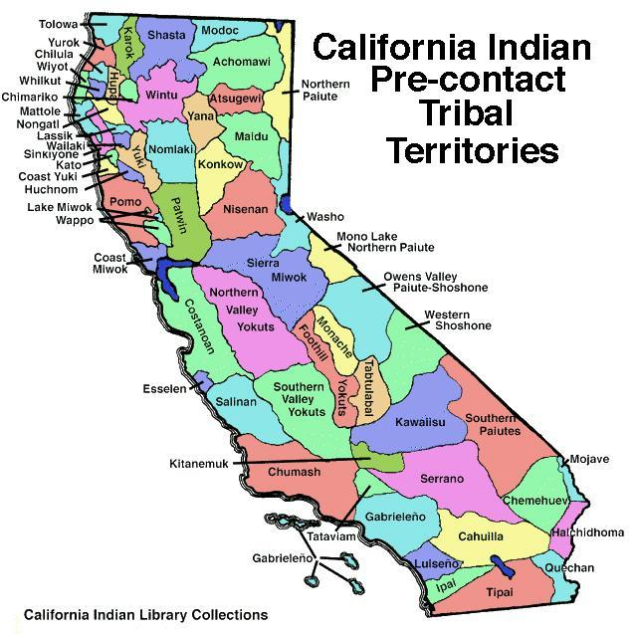
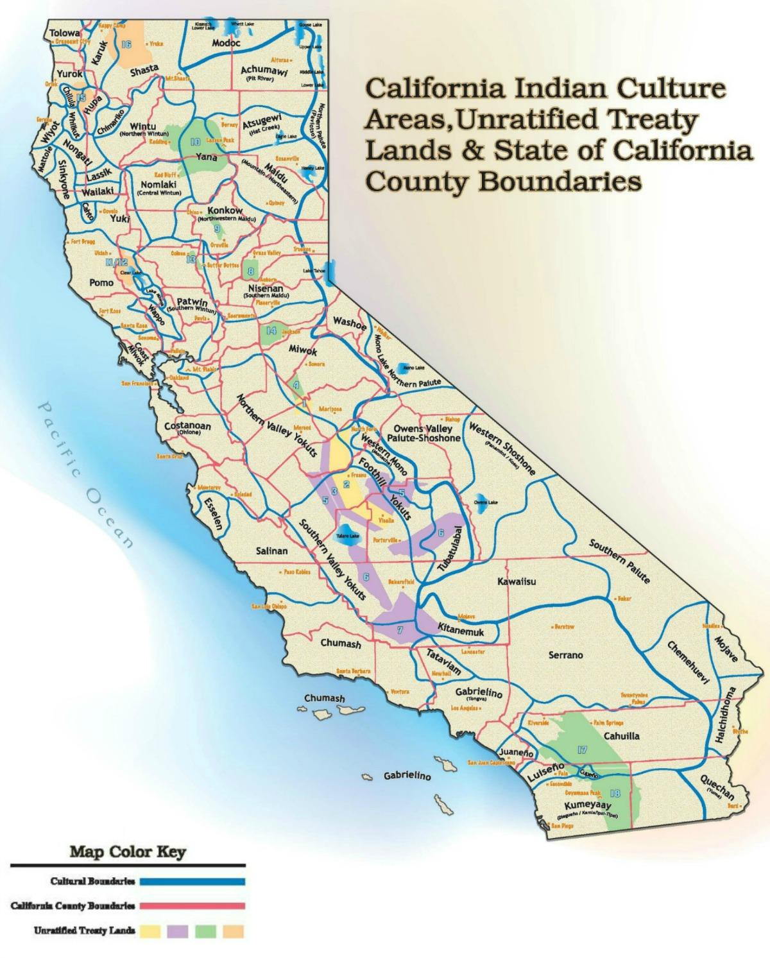
An Introduction to Traditional Ecological Knowledge (TEK)

Although historical knowledge that has developed since time immemorial is critically important to TEK, it is important not to relegate Indigenous knowledge solely to the realm of the past. Many of the practices that inform TEK are in a constant state of flux, and go through cycles of generational regeneration, in response to changes in the environment. TEK is responsive and adaptive, rather than static or unchanging.

The knowledge held by Native peoples does not have to be overtly “ecological” for it to have environmental significance. TEK can be formed through language, stories, folklore, and taboos, in addition to land management and subsistence practices. Many aspects of TEK have incredible spiritual and emotional significance, and therefore TEK is not just a “knowledge” base, but is a way of seeing and interacting with the world.

Fikret Berkes’ definition of TEK is one that is widely accepted and used: “a cumulative body of knowledge, practice, and belief, evolving by adaptive processes and handed down through generations by cultural transmission, about the relationship of living beings (including humans) with one another and with their environment” (Berkes 1999). Nevertheless, in working with Native students and knowledge-holders it is important to remember that no academic definition can truly capture the deeper spirituality and worldview that is evident in traditional ecological knowledge.

TEK In Practice
Intersections between food sovereignty and land management are a useful place to illuminate the importance of TEK. Having cared for the landscapes of the Klamath Basin since time immemorial, much of the TEK held by Native peoples is associated with the hunting, gathering, harvesting, preparing, storing, preserving, and eating of traditional foods. These teachings are inextricably linked with knowledge of how to best manage the forests and rivers to ensure the productivity and sustainability of foods for future years.

Unfortunately, traditional methods of management have been excluded from landscapes for decades, if not centuries, through the overt criminalization of Indigenous land management practices, imposition of Western management regimes, and ongoing structures of land dispossession. Compounded by complexities arising from geographic isolation, poverty, and political marginalization, much of the Native population in Northern California now lives in areas which are deemed as food insecure or as food deserts. In the absence of fresh, affordable, and healthy foods, it is more critical than ever to foster traditional foods and TEK in order to protect the biological, psychological, cultural, and community health of Native communities.

TEK in Collaborations
The effect of non-Indigenous individuals and groups working collaboratively with Tribes on natural resource protection can come at a high cost to Indigenous peoples. Many will not give credibility to Indigenous knowledges for being ‘scientific enough’, and there are also instances of Indigenous knowledges being misappropriated in order to seek financial gain by non-Indigenous people. Because of the disconnect between Western scientific knowledge and Indigenous knowledges, collaboration can become messy. When practiced inappropriately, such collaborations unfortunately tend “to disempower and marginalize Indigenous communities and interests, dismiss their cultural, religious, and other concerns as irrational, and ensure the imposition of external values, interests, and plans in indigenous domains” (Hibbard, et al., 2008).

TEK and Western Science
Many authors attempt to compare and contrast TEK in relation to Western science, but this often fails to recognize that TEK is a science in its own right and does not need to be validated through Western science. Much like the tenets of Western science, generations of observation and adaptation is held within Indigenous land management; more than land management, it is a way of living.

We delineate Western science from TEK to acknowledge the multiple knowledge systems that exist when participating in cross-cultural discussions, research, and teaching; accordingly, we highlight the need to partner with Indigenous knowledge holders to offer leadership on how to best support TEK and Indigenous-focused learning opportunities. We seek to generate equality between knowledge and management systems. The knowledge held by Indigenous peoples has too often been disregarded since it sometimes deters from Western science protocols. This is a dynamic that must be recognized and actively improved if classrooms are to become a space of equality and inclusion for all students.

See this New to TEK: Teacher’s Guide for more information about TEK, Western science, and the Yurok Tribe.

Important Concepts and Definitions

Traditional Ecological Knowledge
Sometimes referred to as Indigenous knowledge or Native science, TEK refers to the evolving knowledge acquired by Indigenous and local peoples over hundreds or thousands of years through direct contact with the environment (Reed, in Speaker Series).
“A cumulative body of knowledge, practice, and belief, evolving by adaptive processes and handed down through generations by cultural transmission, about the relationship of living beings (including humans) with one another and with their environment” (Berkes 1999).

Tribal Sovereignty
Refers to the right of Native peoples within the US to govern themselves. The U.S. Constitution recognizes Tribes as distinct governments who have the same powers as federal and state governments to regulate their internal affairs. Sovereignty for tribes includes the right to establish their own form of government, determine membership requirements, enact legislation, and establish law enforcement and court systems.
Tribal sovereignty predates the US Constitution- sovereignty was not granted by the US government, it was recognized. Therefore Tribal sovereignty exists outside the Constitution and is not dependent on it.

Tribal Hunting, Fishing, and Gathering Rights
Traditional practices of fishing, hunting, and gathering are conceived of as a responsibility to the natural world and to past and future generations. As a result of land dispossession, many Native American tribes’ access to hunting, fishing, and gathering sites were severed and thereby forced tribes to fight for reserved rights to fish, hunt, and gather. During treaty processes, many nations were able to reserve lands and rights to hunt, fish, and gather on such lands. Hunting, fishing, and gathering rights are an act of sovereignty that is essential for the collective continuance of Tribal nations as culturally and politically distinct peoples. Enacting sovereignty through the transmittance of biological and cultural knowledge– via hunting, fishing, and gathering – is an act of resistance to colonialism as well as a continued relationship and responsibility to place (Reed 2020).

Food Sovereignty
According to the Declaration of Nyéléni adopted by 80 nations: “Food sovereignty is the right of peoples to healthy and culturally appropriate food produced through ecologically sound and sustainable methods, and their right to define their own food and agriculture systems.” Indigenous food sovereignty refers to a re-connection to land-based food and political systems and seeks to uphold sacred responsibilities to nurture relationships with our land, culture, spirituality, and future generations. Indigenous food sovereignty is not only focused on rights to land, but also responsibilities to and relationships with elements of food production systems and connects health of food with the health of the land.

Environmental (In)Justice
Refers to the disproportionate exposure of low income, Indigenous, and communities of color to conditions of pollution and environmental degradation and their subsequent effects on health and wellbeing, as well as the unequal making and enforcement of environmental protections provided through regulations.

Environmental Racism
Refers to the disproportionate impact of environmental hazards on people of color. Communities of colour are disproportionately forced to live in proximity to sources of toxic waste such as sewage works, mines, landfills, and power stations; this is facilitated by governmental regulations that purposely direct or do not regulate industrial infrastructure and pollution within communities of color. As a result, these communities suffer greater rates of health problems. For example, there is such a concentration of industrial activity and waste within the predominantly African-American communities between Baton Rouge and New Orleans that the area is now dubbed “Cancer Alley.”

Benjamin Chavis coined the term “environmental racism” in 1982 to refer to: “racial discrimination in environmental policy-making, the enforcement of regulations and laws, the deliberate targeting of communities of colour for toxic waste facilities, the official sanctioning of the life-threatening presence of poisons and pollutants in our communities, and the history of excluding people of colour from leadership of the ecology movements”.

Settler-Colonialism
Is a distinct form of colonialism which is premised within the erasure and replacement of Indigenous peoples by a settler population. Unlike European “resource colonies” such as India or Indonesia, settler’s “come to stay” in settler colonies- they seek to make a permanent home and assert sovereignty over the territory, thus, there is no moment of post-colonial independence as in other forms of colonialism. However, settler colonialism is not a moment of invasion in the past, but is an ongoing structure that seeks to occupy and assert control over Indigenous lands in the present day. Examples of settler-colonies include the US, Canada, Australia, New Zealand, and South Africa. According to Patrick Wolfe (1999; 2006), a key historian of settler societies, theft, occupation, and ownership of land is the central underlying element of settler-colonialism.

An Introduction to Water Issues in California

A Complicated System
California’s state and federal water projects are possibly among the most complicated water systems in the world. The system utilizes at least 40 large dams and impacts the Sacramento, Pit, McCloud, Feather, San Joaquin, American, Klamath, Trinity, and several other watersheds. A complicated system of ditches and canals carries this water for hundreds of miles to cities and farms in Central and Southern California.

Dams and Diversions
Most of California’s rivers are heavily dammed and diverted, which has left rivers- which are also drinking water supplies- largely without water and full of toxic algae and agricultural chemicals. Histories show that Native American allotments and village and sacred sites have been targeted for the placement of the state and federal dams. Most of the dams do not have fish passage, which means the projects have left many of California’s Tribes without a land base (e.g. due to flooding for dam-building), clean water, or salmon- a vital food source. Furthermore, some of the project remains unfinished and water users have not paid the federal government back for building the dams and diversions, which has led to a lack of upkeep and complicated ownership and regulatory framework.

Agriculture and Environmental Justice
Some of the areas where the water is moved are called the “poisoned lands” of California. These desert lands in the Western San Joaquin Valley have shallow groundwater full of toxins and pesticides that need to be drained to make it farmable. This situation led to one of the state’s worst environmental disasters at the Kesterson Wildlife refuge. Now the water is drained into the San Joaquin River and Bay Delta, and thus millions of Californians are drinking toxic and dangerous water.

Wetlands
California’s rivers and wetlands have also been drained and channelized, leaving little remaining flood plains or functioning estuaries. This greatly impacts water quality and fish because floodplains and wetlands provide natural filtration and productive feeding zones. It is also a recipe for climate-related disaster and flooding, as these areas catch excess water and replenish groundwater supplies. Climate change is expected to cause more droughts and flooding. Restoring these areas is critical to protecting the state’s water supply and communities. Wetlands were also extremely important food sources and cultural areas for local Tribes, who actively managed them to provide food for their people and to help the functioning of the environment.

Water Rights
California has a complicated legal and physical water framework. The state has a very outdated water rights system that allocates over ten times as much water as actually exists and encourages waste. This water rights system is in direct conflict with the state constitution that demands water use be in the public interest. This water rights system leads to yearly water struggles and lawsuits and sometimes leaves towns and cities without water, while grazing fields are flood irrigated.

The Need for Reform
It would be hard to imagine setting up a system that could be worse for environmental justice and the people of California. This is why it is critical that the people of California work with the state to reform it.

On Grading, Discussions, and Options for Participation

Grading is a required aspect of state education and we recognize the importance for teachers to be able to quantify where students stand relative to their classmates and students nationally. However, because we strive to foster community, critical thinking skills, opportunities for personal reflection, and create an inclusionary space for learning- particularly for Native students- we do not wish this curriculum to be used in ways that reinforce grading disparities that tend to have disproportionate negative effects on Native students.

We suggest that assignments be graded on a pass/fail system that considers student effort and intent. For example, in writing an op-ed article (session 3.3), if the student has clearly put effort and thought into their assignment, they should receive equal credit as other students even if they might have below average writing skills. Similarly, many students do not have access to the internet and other digital or research materials- this should not affect their grade as long as they demonstrate a willingness to learn and engage. This is an opportunity to foster practice, collaboration, and critical-thinking, instead of penalizing students for problems that are likely no fault of their own.

We assert that there should be various options for students to demonstrate what they are learning. In this vein, we have crafted assignments that incorporate artwork, digital design, social media, mapping, personal reflections, and group learning, in addition to more traditional writing and question-and-answer assignments. This is intended to provide options for both educators and students.

Some of these activities (particularly the webinar reflections and comprehension questions) could be answered several ways, such as through writing assignments, classroom discussions, or video submissions. Some students struggle with writing, while others do not feel comfortable speaking in front of the whole class. We urge educators to recognize the various ways in which students learn and engage with material, and give equal weight to different forms of participation.

Additional Resources

Educational Videos

Roundtable presented by the NCIDC and ACLU of Northern California discussing the December 2020 Report, Failing Grade: The Status of Native American Education in Humboldt County Native American Report Card Humboldt County

History of Native California, Presented by HSU’s STEM Place-Based Learning Communities, featuring Indigenous leaders from Northern California (13 mins)

The Forgotten Tribes: Truth About Federally Un-Recognized Tribes in the United States

Why it’s Time to Give Native Americans Their Land Back (8 mins)

Tending the Wild, 6 Part Series

Humboldt State University’s Food Sovereignty Speaker Series

Dr. Torie Weiston-Serdan’s “Critical Mentoring: Because Young People Deserve the Best of Us”

US Alliance for Food Sovereignty- Food Sovereignty Stories

University of Pittsburgh School of Education Roundtable on Equity, Anti Racism, and Remote Teaching and Learning Strategies

Language Keepers: The Struggle for Indigenous Language Survival in California

Educational Articles

California Water 101, Water Education Foundation

Decolonizing the Classroom: A Conversation with Girish Daswani

California Executive order N-15-19

Governor Newsom’s September 25, 2020 Proclamation
Governor Newsom’s Apology for Historical Wrongdoings

Sacred Water, Klamath People and the Struggle for Cultural Survival

Salmon as a Sacred Resource in the Klamath River

Four Principles for Trauma-Informed Distance Learning

Seeing Our Native Students: A Guide for Educators, by Redbud Resource Group

Media Articles

Pulling Down Our Monuments: Apology from the Sierra Club regarding Histories of Environmental Racism

Decolonizing Ecology, Briarpatch Magazine

Environmentalism's Racist History, The New Yorker

‘Monuments of Colonialism’: With Klamath Dam Removal at an Impasse, Huffman Calls Congressional Forum. Lost Coast Outpost

The Problem with Wilderness

Governor Newsom Issues Apology to Native Americans for State’s Historical Wrongdoings, Establishes Truth and Healing Council

Other Curriculum Examples

Healthy Ecosystems Feed Healthy Communities, Redbud Resource Group Lesson Plans

Lessons of Our Land- Includes Pre-K-12 Sample Lessons

Kumeyaay Heritage and Conservation Project: Learning Landscapes and Educational Curriculum

Yurok TEK Curriculum

Learning in Places Curriculum for Seasonal and Field-Based Science Education

Winnemem Wintu Run 4 Salmon Curriculum

Educational Activities

Salmon Life Cycle Vocabulary Game- Teacher’s Guide

Wild Salmon Center’s Salmon School

Salmon Life Cycle Vocabulary

Pacific Salmon Foundation’s Salmon Vocabulary Game

“Rose and Thorns” Ice-Breaker Class Discussion Activity

Online Tools

Model My Watershed

National Geographic Map Maker Interactive

Digital Atlas of California Native Americans

https://native-land.ca/

Flipgrid

Jamboard

prezi.com

doodly.com

Esri EarthViews

Canva

Additional Readings

Dowie, Mark (2009) Conservation Refugees: The Hundred Year Conflict between Global Conservation and Native Peoples. MIT Press.

Kyle Whyte (2018) Settler Colonialism, Ecology, and Environmental Injustice. Environment and Society (9)1: 215-144.

Holmes, Henry (1992) “The Color of California Water Politics,” Race, Poverty, and the Environment, Special Issue on Water (3) 2: 25-28.

Scoville, Caleb (2015) Reclaiming Water Politics: California’s Drought and the Eclipse of the Public. Berkeley Journal of Sociology, (59) 35-43.

Melanie Yazzie and Cutcha Risling Baldy (2018) “Introduction: Indigenous peoples and the politics of water” Decolonization: Indigeneity, Education and Society (7)1: 1-18

Jaskiran Dhillon (2019) What Standing Rock Teaches Us about Environmental Justice. In Standing with Standing Rock: Voices from the #NoDAPL Movement.

Beth Rose Middleton, Morning Star Gali, and Darcie Houck (2018) “Holding the Headwaters: Northern California Indian Resistance to State and Corporate Water Development,” Decolonization: Indigeneity, Education and Society (7)174-198.

McCully, Patrick (2001) Silenced Rivers: The Ecology and Politics of Large Dams

H. Gosnell and E. C. Kelly (2010) “Peace on the River? Social-Ecological Restoration and Large Dam Removal in the Klamath Basin, USA,” Water Alternatives, (3)2: 361-383.

Native American Studies in Higher Education: Models for Collaboration between Universities and Indigenous Nations (edited by Duane Champagne and Jay Stauss)

Indigenizing the Academy: Transforming Scholarship and Empowering Communities (edited by Devon Abbott Mihesuah and Angela Cavender Wilson)

Tara J. Yosso (2005). “Whose Culture Has Capital? A Critical Race Theory Discussion of Community Cultural Wealth.” Race Ethnicity and Education 8:1 (69-91).
Kimberly D. Tanner (2013). “Structure Matters: Twenty-One Teaching Strategies to Promote Student Engagement and Cultivate Classroom Equity.” Life Sciences Education 12: 322-331.

